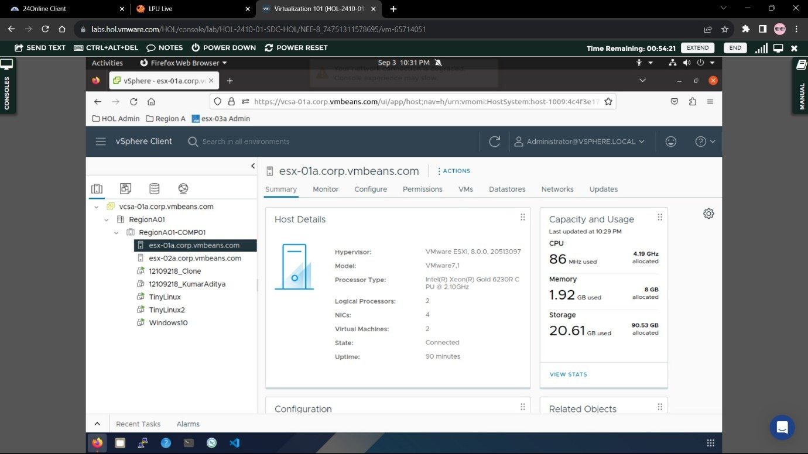
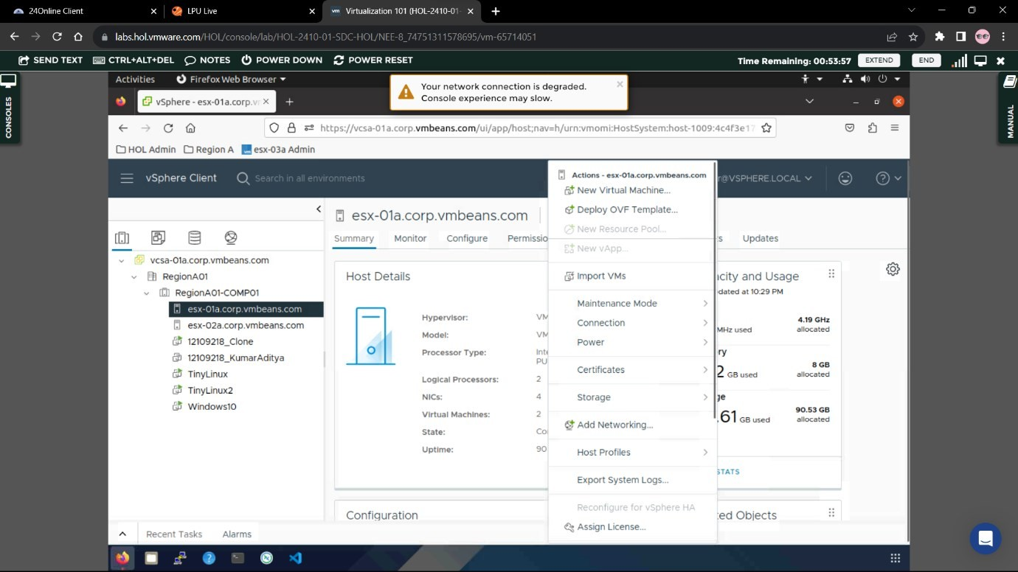
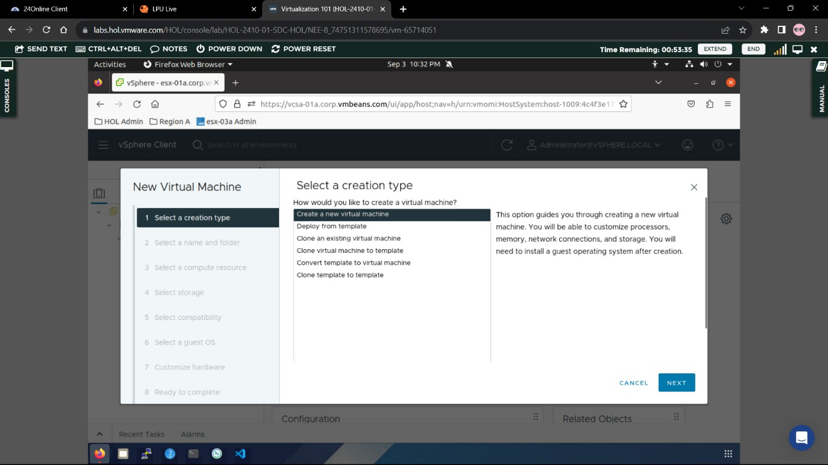
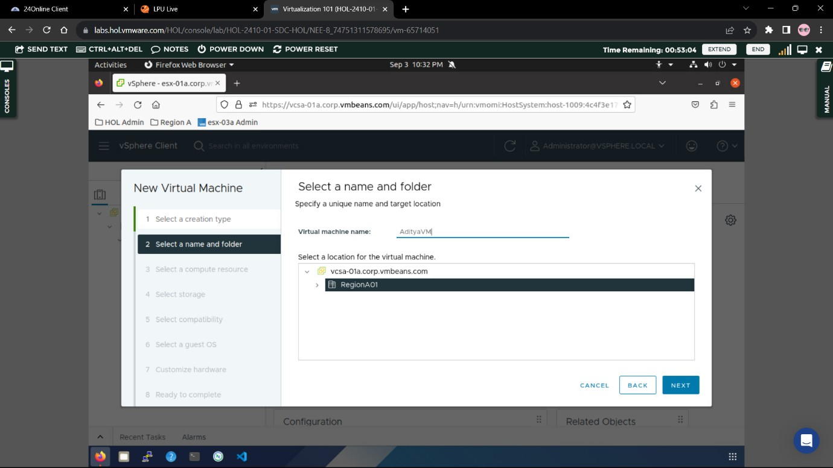
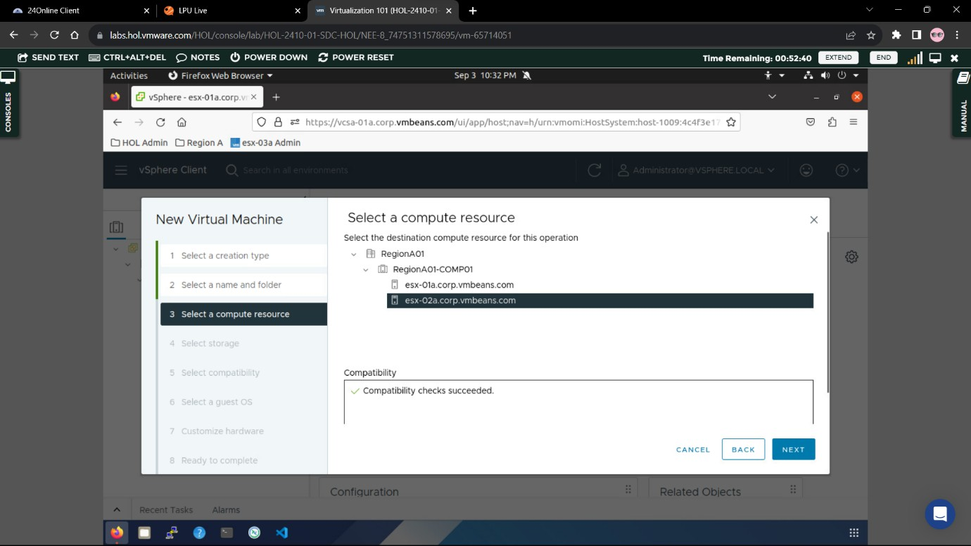
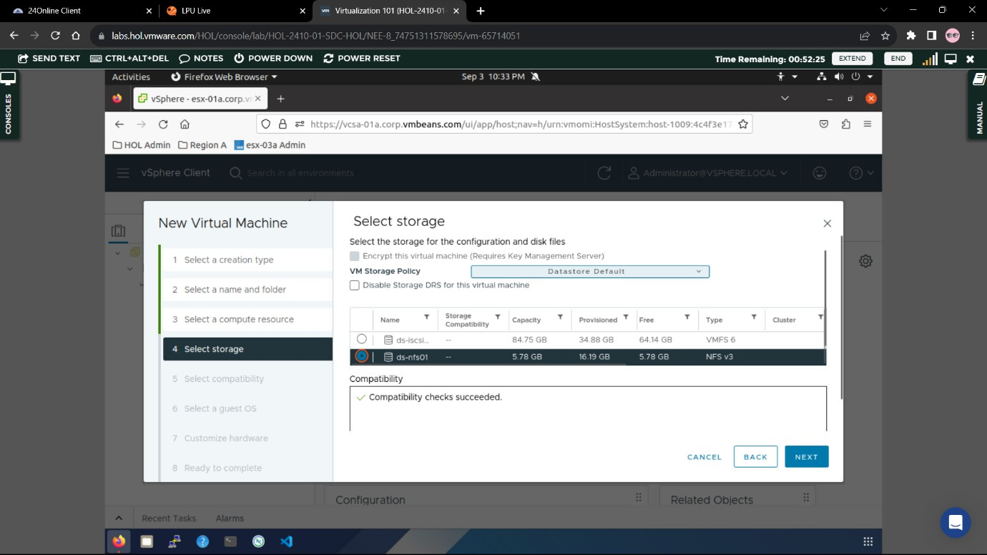
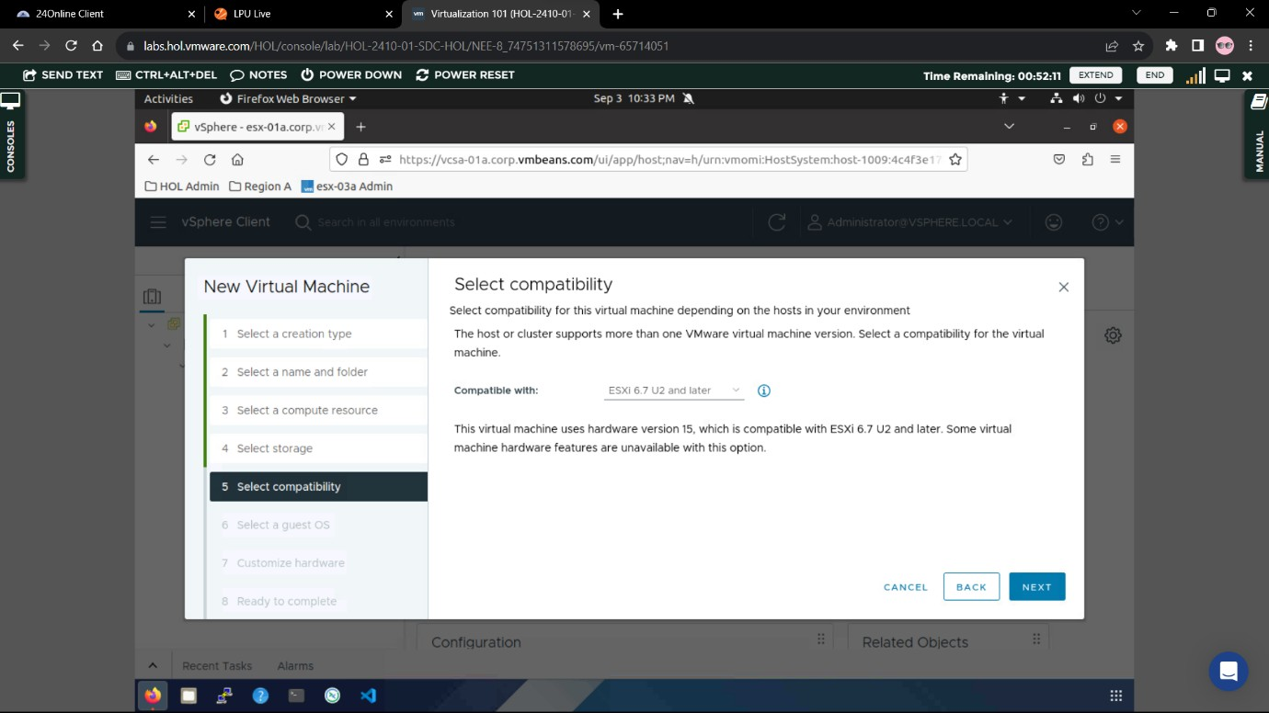
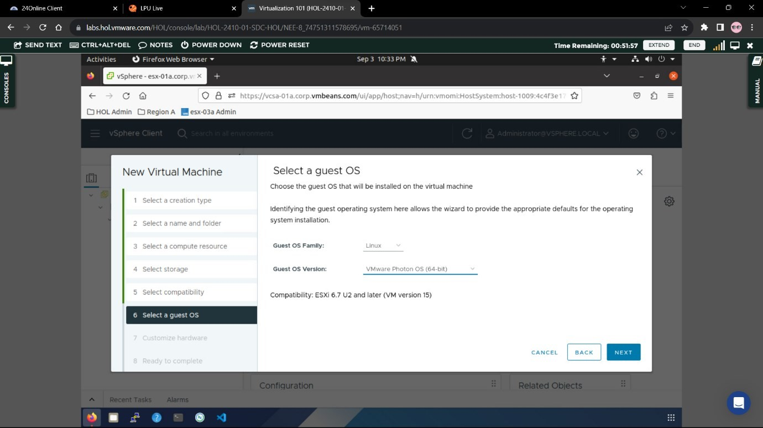
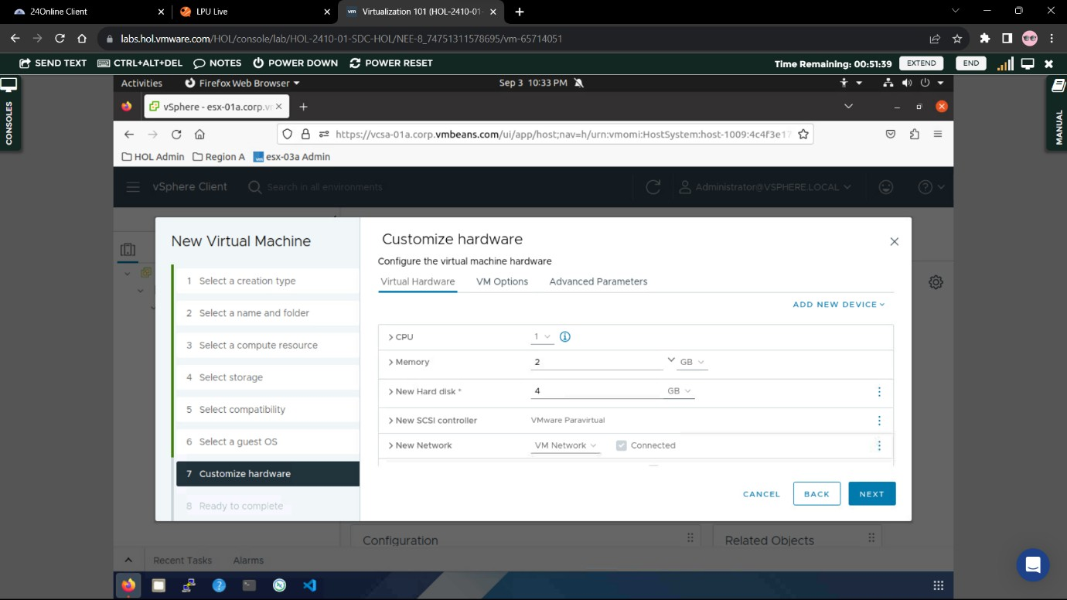
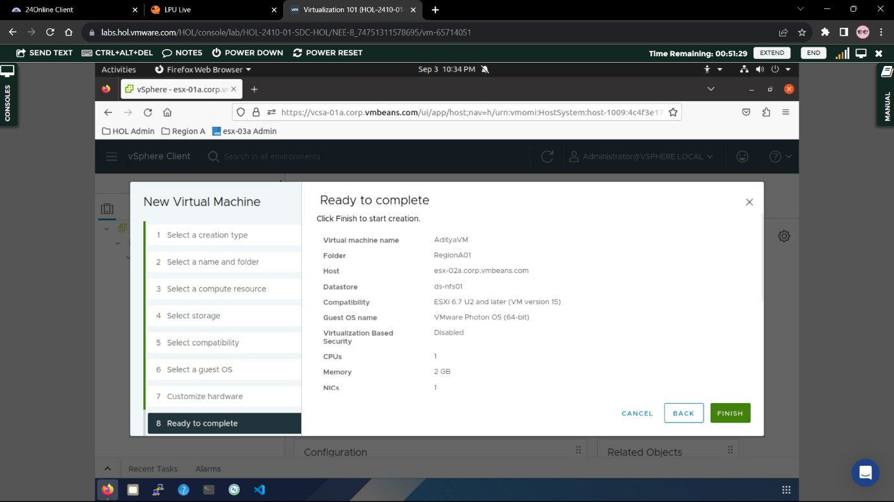
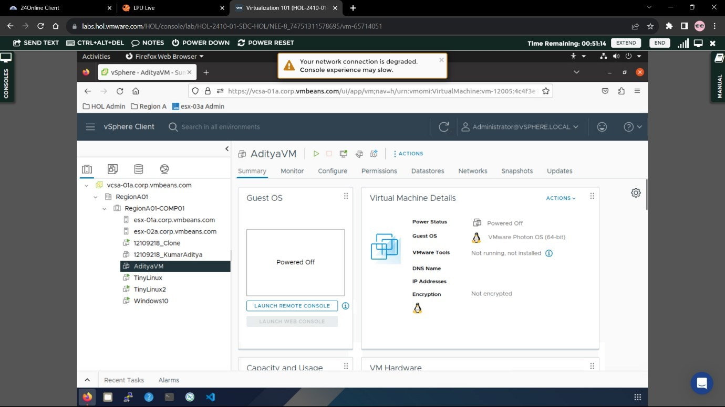
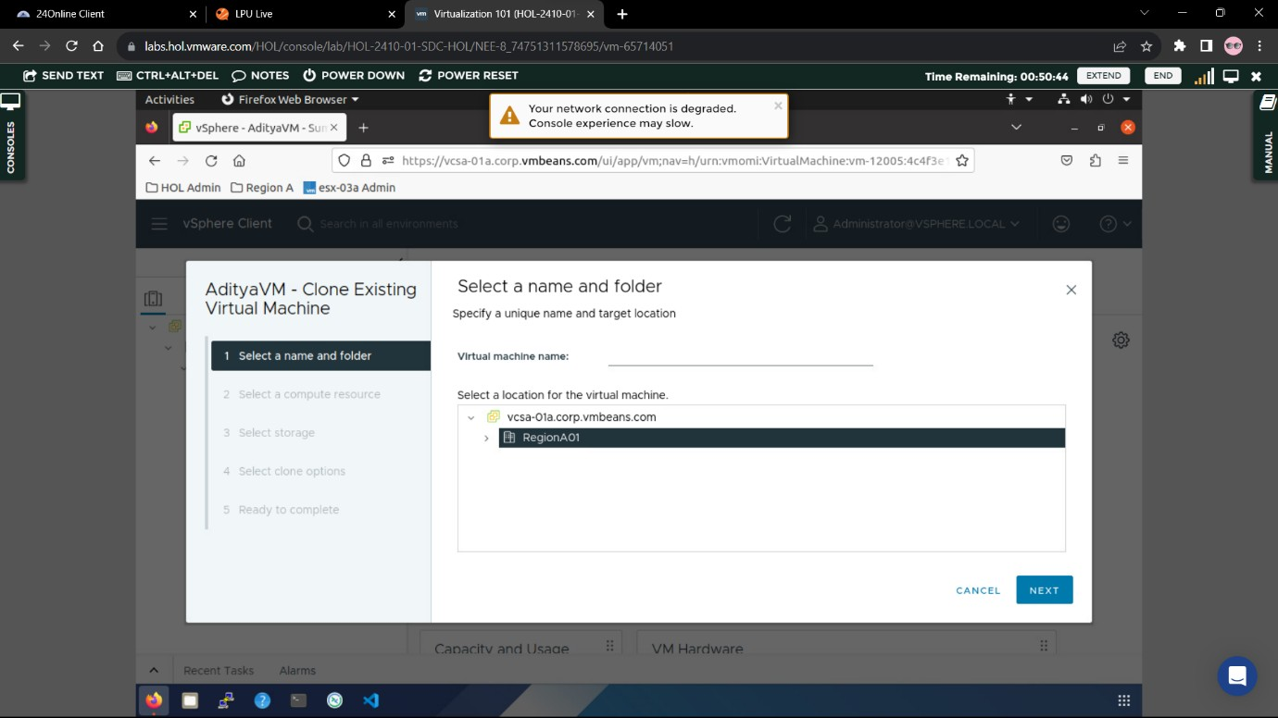
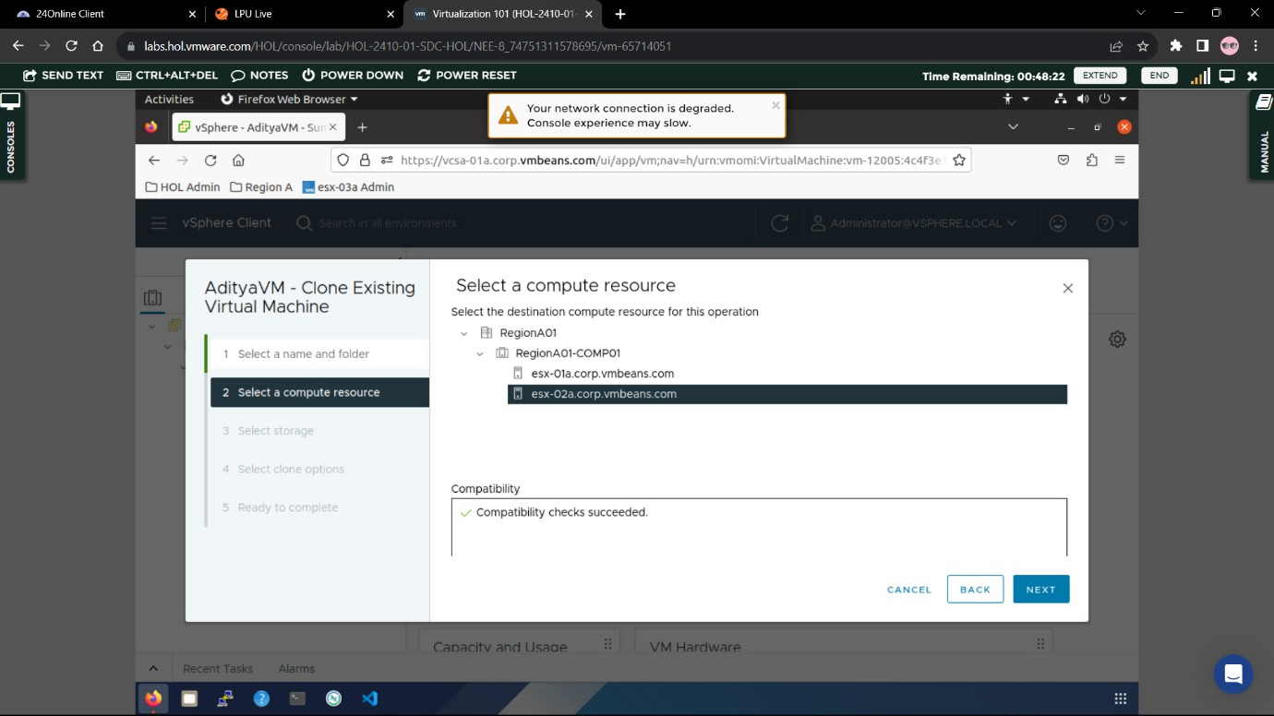
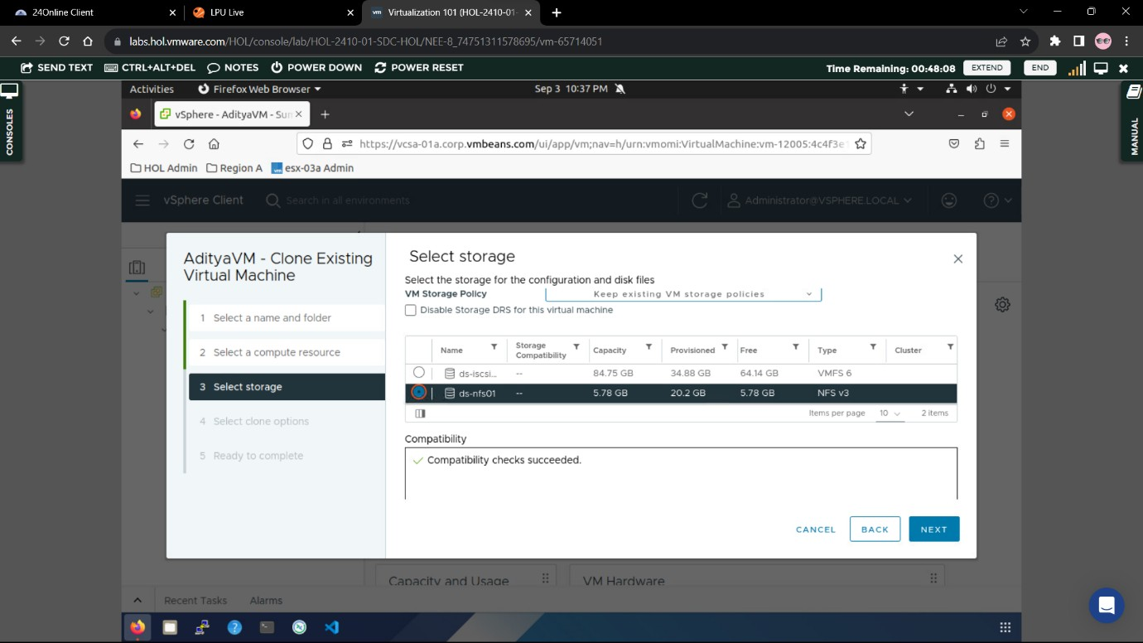
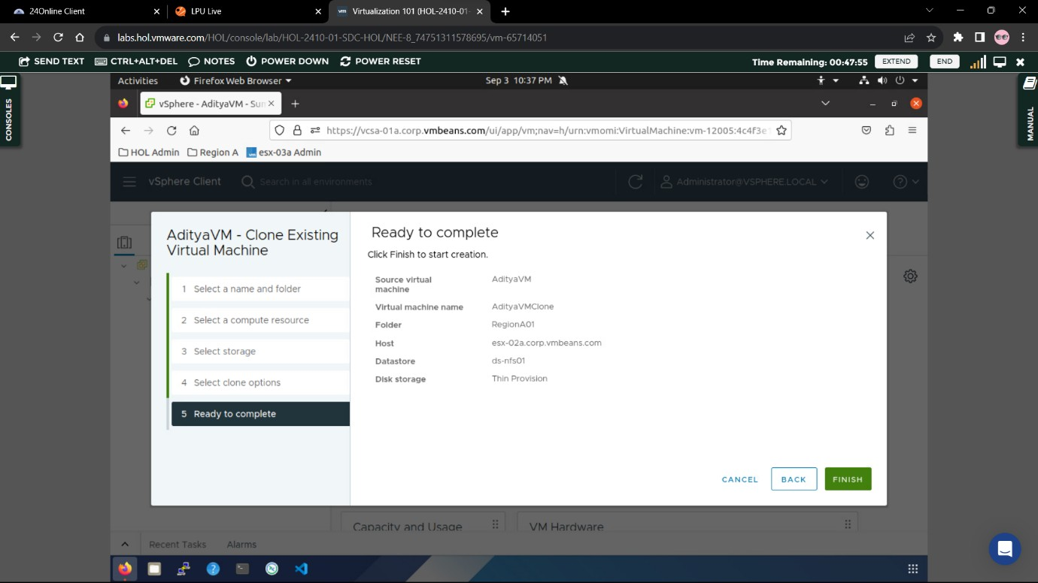

Name : ADITYA RAJ

Regno : 12214315

Rollno : K21BG

- Provide a name for your virtual machine .

- Select the resources .

- Select NFS01 as storage for the virtual machine .

- For Compatibility choose the option from the drop down menu called (ESXi
6.2 U2 and Later) .

- Select Linux as Guest OS Family and VMWare Photon as the version .

- Customize hardware according to your suitability .

- Finalize to create the virtual machine .

- Now we need to create a clone for the existing VMWare virtual machine .

- Select the resources for the clone machine .

- Select storage for the Virtual Machine Clone .

- Finalize the settings to complete the clone installation .

